Wheatstone Bridge

Introduction

Most introductory physics courses contain problems of objects flying through the air or rolling along the ground without considering the effects of wind resistance. One of the main reasons why wind resistance is left out of consideration is that its addition to the problem makes the equations of motion almost impossible to solve, as the force term for wind resistance depends on velocity of the object to some power. An equally important reason is that the effect of wind resistance is minor for a great many of the problems that investigated in such a class. For example, objects that are thrown through the air at 5-10 m/s are affected minimally by wind resistance, as its effect is to cause the ball to fall only about 1-2% short of its intended target, which is a fairly small amount.

In the world of electronics, this situation is much different. Resistive effects can be quite large. Even excellent conductors like copper, gold, and silver provide a healthy amount of resistance to the flow of electrons through them. One way to see this is to touch the wire going to an appliance that draws a lot of current, such as a refrigerator, air compressor, or microwave. If the appliance has been on for quite some time, the wire will be warm to the touch, as the resistance in the wire will cause energy to be lost and heat to be created. It is the rare case of special substances called superconductors that must be chilled below liquid nitrogen temperatures in which the effects of resistance can be ignored.

When it comes to electricity and humans, large resistances can be good things. As discussed in the Capacitor Activity, the membranes of the nerve and muscle cells in our body operate as a capacitor to keep ion concentrations/charges separated to maintain an electric potential between the inside and the outside of the cell. Whenever external currents enter the body, such as when you touch a loose wire or get struck by lightning, they will disrupt the charge distributions in the body. If the external currents are very small (micro amps and less), this might cause slight to no damage. Mostly, currents of this size will cause muscle cells to contract as the extra negative charges flowing through the body change the potential difference across the membranes, causing all of the channels in the membrane to open up and allow ions to flow. As long as the currents remain away from critical muscles, such as the heart, there is merely a tingling sensation as the nerves and muscle cells are activated. At higher levels, though, these currents can do severe damage, as they will physically damage the membranes and cause cell death.

Thus, limiting the amount of external current that can enter the body is considered a wise maneuver. One way to do this is to increase the overall resistance of the body whenever it is near electrical wiring. Wearing rubber soled shoes or rubber gloves are two ways to do this; another is to stand on dry land instead of a puddle of water. You can also lower the lethality of any electricity that does enter the body by preventing it from going near the heart by always keeping one hand behind your back attached to your belt or other clothing.

Theory

When it comes to electricity, materials can be placed into one of three categories: insulators, conductors, and semiconductors. A perfect insulator would be a device that completely resisted the flow of electricity through it. A perfect conductor would be a device that allowed electricity to flow through it with no impedance. Of course, almost all materials do not fit either of these profiles, and so our definition of what falls into these categories must be slightly modified. Insulators are devices that almost completely resist the flow of electricity through them. There is some small amount of electricity that will leak through them, and under a large enough potential difference, these materials might even break down and allow electricity to flow quite well. A great example of this is lightning travelling through air, which normally is a good insulator. The reverse holds true for conductors (see above), which allow electricity to flow through them without too much impedance. Semiconductors are the middle ground between the two, acting like insulators under certain conditions and conductors under others. Diodes are the simplest example of a semiconductor, allowing electricity to flow in one direction, but not the other.
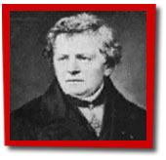
Fig. 1: Georg Ohm (Energyquest)
The earliest studies of electricity showed that most conductors have a similar profile in how they transmit electricity. As discovered by Georg Ohm in 1827, the current flowing through a conductor will be linearly dependent upon the voltage applied to it. This relationship, known as Ohm’s Law, can be stated mathematically as

V = IR

where V is the applied voltage, I is the current, and R is the proportionality constant known as the resistance. Materials that follow this equation are now known as ohmic devices and include most metals found in nature. The resistance for these types of materials was found to have a very simple form, being inversely proportional to the cross-sectional area to the current flow through the material and linearly dependent on the length of the material. Mathematically, this is

$\text{R }=ρ\frac{L}{A}\text{L/A }$ (Equn. 1)

where L is the length, A is the cross-sectional area, and ρ is the resistivity of the conducting material. The resistivity depends only upon what the substance is composed and what its temperature is (for most materials, the hotter it is, the more resistivity it has). This equation shows that the longer a wire is, the more resistance it has. It also shows that the thicker a wire is, the less resistance it has. This equation shows why you should never use a cheap, thin extension cord to power devices that require a large amount of current, such as air conditioners or refrigerators. The thinness of such a cord means that it has a lot of resistance, which will limit the amount of electricity that you can supply to the device, thus causing a burnout.
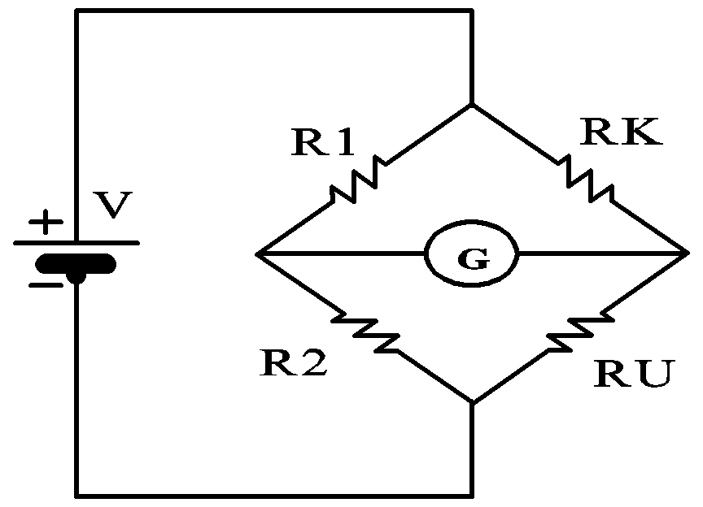
Fig. 2: Wheatstone Bridge apparatus

Model

In this week’s lab, we will test this equation with the aid of a Wheatstone Bridge apparatus. Figure 2 shows a diagram for a Wheatstone bridge circuit. This circuit consists of four resistors connected in a box configuration with a galvanometer connected to the junction between the resistors that is "perpendicular" to the current. Three of these resistors have known resistance, while the fourth is yet to be determined.

For this experiment, two of the known resistors (R₁ and R ₂) are provided by a 1.00 m long conducting wire that may be tapped at any point along its length to divide its total resistance into two parts. The resistor R_{K} has a known resistance that is measured with a multimeter. The resistor R_{U} is the resistor of unknown resistance. By moving the point at which the 1.00 m long wire is tapped, a situation can be reached in which the current flowing through the galvanometer is zero. When this occurs, this means that the potential difference across the galvanometer is zero. At this point, we let I₁ designate the current flowing through resistors R₁ and R₂ and I₂ be the current flowing through resistors R_{K} and R _{U} , then

I₁ R₁ = I₂ R_{K}
I₁ R₂ = I₂ R_{U}

Dividing the second of these equations by the first, and solving for R_{U}, yields

$$R_{u} =\frac{R_{2}}{R_{1}}{\text{ R}}_{k}$$

Since R₁ and R₂ are formed from the same wire conductor, when equation 1 substituted into the last equation, the result is
$R_{u} =\frac{L_{2}}{L_{1}}{\text{ R}}_{k}$ (Equn. 2)
where

L ₁ and L₂ are the lengths of the conducting wires forming R₁ and R₂.

In this experiment the use of equation 2 above depends upon the linear relationship between resistance and length of a conducting wire described in equation 1. Therefore, verification of the linear relationship between resistance and length of a conducting wire of uniform cross-sectional area must precede measurements with the Wheatstone bridge.

The first objective of this experiment is to verify that linear relationship. This will be accomplished by placing a constant potential difference across the full length of the wire and measuring the voltage drop across a variety of partial lengths of the wire. Since the current in the wire is constant, the voltage drop across a given portion of the wire is proportional to the resistance of that portion of the wire. Thus, a graph of voltage drop versus wire length should be a straight line.

For the second objective, a single known resistance will be used to in the Wheatstone bridge apparatus to determine the resistances of a variety of resistors. The actual values of the resistances will be determined using a multimeter and the percent discrepancy in the results will be calculated.
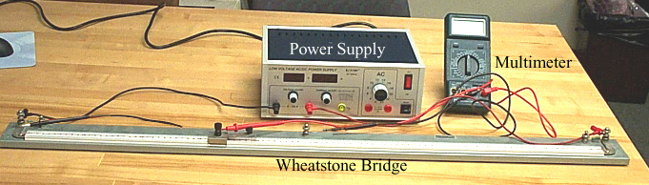
Fig. 3 Set up for Part One

Procedure

The equipment for this activity consists of a voltage supply, a multimeter, a galvanometer, wires with appropriate clips, two resistors, and a Wheatstone bridge apparatus (see Fig. 3). If you do not have a Wheatstone bridge apparatus, check with a science instrumentation company such as Cenco.

Part One

- Secure the necessary lab equipment seen in Figure 3. Connect both ends of the Wheatstone Bridge apparatus to the d.c. power supply. Connect the positive end to the end closest to 1 m, and the negative end to the side closest to 0 m.
- Connect the ground end of the multimeter to the end of the Wheatstone Bridge apparatus closest to 0 m (Figure 3). Connect the other end of the multimeter to the sliding rail on the apparatus.
- Turn on the power supply, and adjust the voltage supply until it is about 1 V.
- Starting at 95 cm and sampling at a rate of every 5 cm, sample the voltage along the wire using the slide rail. Record your results on the activity sheet.
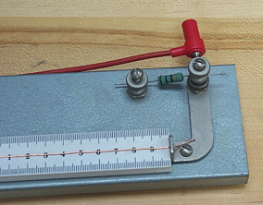
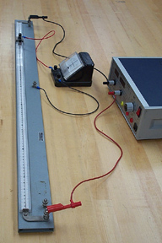
- Plot the results on a voltage versus distance plot. Is the result linear? Why or why not?
Fig. 4: Part Two

Part Two: For the second part of the experiment, we are going to use the relationship that you found in Part One to determine the resistance of an unknown resistor. For this, we are going to need all of the apparatus in Part One with the addition of a galvanometer and several resistors.

- Measure the resistance of the known resistor using the multimeter.
- With the apparatus set up as in part one, attach both resistors between the post at each end of the bridge apparatus (see small inset picture to right).
- Connect one end of the galvanometer to the center bridge (see Figure 4) and the other end sliding rail.
- Apply a low voltage to the circuit. Slide the rail up and down the meter stick until you find the point at which the multimeter measures 0 current. Write down the distance and calculate the resistance of the resistor using Equation 2.
- Measure the resistance using the multimeter and calculate the percent difference between the two.
- Repeat this for two other unknown resistors.

Project IBEAM | Activity Sheet  Wheatstone Bridge

Name:

Part One:
L (cm) | 95 | 90 | 85 | 80 | 75 | 70 | 65 | 60 | 55 | 50 | 45 | 40 | 35 | 30 | 25 | 20 | 15 | 10 | 5
V (V)

Plot this table of results and attach.

1. Is the plot linear? What could explain (random and/or systematic errors) the deviations that you see in the plot from it being linear?

Part Two:

Resistor | L | R_{calculated} | R_{measured} | % Difference
1
2
3

1. How close was your measured value to the calculated value for the resistance? Are there any random or systematic errors that could account for these differences?

