Magnetic Induction

Introduction

Oersted’s observation that a current creates an magnetic field was really only part of the discovery. An application of Newton’s Third Law shows that there is more to learn from this situation. If a moving charge can apply a force to a magnet (the current in the wire making the compass deflect), then the Third Law tells us that a magnet can apply a force to a moving charge. Therefore, if you place an appropriately oriented magnet near a current-carrying wire that is free to move, you should see that the wire is accelerated away from its initial position. This is, in fact, the basis for a motor, where current-carrying wire coils are deflected around an axle when in the presence of a magnetic field.

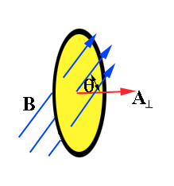
However, this is not the end of the discovery. The movement of the charges the above discussion is being provided electrically by a potential difference. But what if the charges were being moved mechanically? Or better yet, what if the charges themselves were static, but the magnet was moving? In such a scenario, the appropriate orientation of the movement and the magnetic field can cause the charges to move along the wire, thereby creating a current.
Fig 1: Magnetic flux through A

Induction

This was shown in 1831 by Michael Faraday, who reasoned that the conservation of energy principle applied to Oersted’s discovery should result in such a situation. He was able to quantify these observations with an equation that related the induced electromotive potential to the rate at with the magnetic flux changed within a closed loop, such as a circuit, i.e.

$\text{emf }=\text{ -N }\frac{\text{ΔΦ}}{Δt}$ where

Φ is the magnetic flux through one coil, and N is the number of wire coils. The flux is equal to the product of the magnetic field through a single coil times the area of the coil times the cosine of the angle between the magnetic field and the perpendicular to the coil (see Figure 1). This equation shows that the voltage induced in a closed loop depends upon how quickly the magnetic flux (the perpendicular magnetic field times the area of the loop) through the loop is changing.

There are many ways to get the magnetic flux through a closed loop to change. In this experiment, we will do this by having a bar magnet, released from rest, fall freely along the central axis of a solenoid. While the magnetic field of a bar magnet is a complex function of position, we can greatly simplify the problem by confining the magnet to moving along the central axis of the solenoid. The rate of change of the magnetic flux through the solenoid will be larger if the magnet is moving faster. Thus, we would expect the induced emf to be directly proportional to the speed of the magnet.

Lenz's law requires that a current be produced in the solenoid to create a magnetic flux that opposes the change in magnetic flux produced by the falling magnet. As a result a magnetic field opposite that of the bar magnet is produced as it approaches the solenoid, and in the same direction as that of the bar magnet as it leaves the solenoid. This means that the falling bar magnet will feel forces other than that due to gravity. However, the weight of the bar magnet is much greater than the magnetic forces, and we will approximate its motion as free fall. Thus, the speed of the center of the bar magnet released from rest as it passes through the center of the solenoid is given by
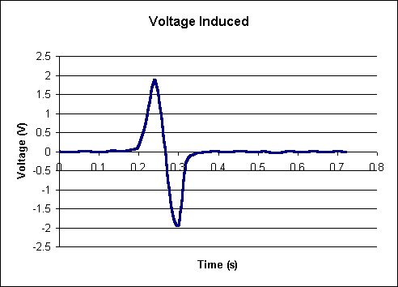
Fig. 2: Voltage from drop magnet through coil
$$\text{v }=\sqrt{\text{2gh}}$$

where h is the original height of the magnet above the solenoid and g is the acceleration due to gravity.

The plot in Figure 2 shows the induced voltage in a solenoid of N=1000 turns by dropping a bar magnet from a height of 20 cm. The emf as a function of time shows a maximum and a minimum (the student is responsible for explaining the reasons for the variation of emf with time). The variation in emf may also appear as a minimum followed by a maximum, depending on the pole of the magnet which first enters the solenoid and the polarity of the connection used to measure the emf. The midpoints of the bar magnet and the solenoid coincide at the time when the emf is zero between the maximum and minimum. In order to make comparisons of the emf at different speeds of the bar magnet, we will use the average of the magnitudes of the maximum and minimum emf. To test the relationship between emf and rate of change of magnetic flux, a graph of the average of the magnitudes of the maximum and minimum induced emf’s versus speed at the midpoint will be constructed. Based on the discussion in this section, the relationship should be linear.

Procedure

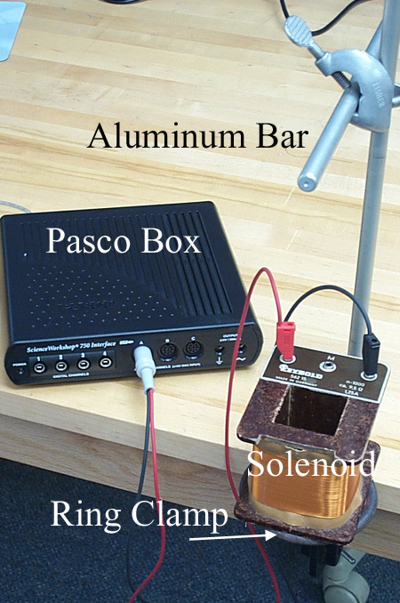
For this activity, you will need a bar magnet, a solenoid, a meter stick, a table stand with 1 ring clamps and one 90º clamp, an aluminum bar, a large clamp, a foam cushion, and a Pasco voltage probe.
Fig. 3: Set up

- Set up the equipment as in Figure 3. Make sure that the position of the upper aluminum bar is over the middle of the opening of the solenoid. Mark the position on the bar that is the center.
- Position the aluminum bar a distance of .1 meter above the center of the solenoid.
- With the magnet in position over the solenoid (the middle of the magnet should be even with the bar), start the Pasco software.
- Drop the magnet through the solenoid, and record the maximum and minimum voltages using the Pasco interface. Make sure that the magnet lands on the foam cushion.
- Repeat this twice more at this height, averaging the absolute value of the maximum and minimum voltages. Record this data on the activity sheet.
- Raise the bar .1 meter and repeat steps 3-5. Continue until you reach a height of .5 meters.
- Calculate the speed of the bar at the middle of the solenoid when dropped from each height
- Plot the average voltage magnitude versus the height.
- Answer the questions on the activity sheet.

Physics Activities | Activity Sheet  Magnetic Induction

Name:

Height | Min 1 | Max 1 | Min 2 | Max 2 | Min 3 | Max 3 | Average | Speed
.1 m
.2 m
.3 m
.4 m
.5 m

1. Does the plot of the data form straight line?

a) If it does, what is the slope of the line? What does this slope value mean?

b) If not, what shape does it form? Is there any significance to this shape?

2. How do the systematic and random errors involved in this experiment affect your results?

