Electromagnets

Introduction

Mankind’s knowledge of magnetism is nothing new; people have known of its existence for millennia. The term “magnet” comes from the ancient Greece word “Magnesia”, which is the place in Thessaly where the naturally occurring magnetic rock lodestone was found in the BCE era. While its existence was realized very early, a use for it other than as an interesting toy demonstration did not come about until about the 12th century CE, when chunks of lodestone attached to pieces of wood were floated in water as a crude compass for navigating ships in Europe. This use revolutionized ship travel and led to a massive exploration (and subsequent conquering) of the world by European navies¹.

However, the ability to create magnetism is a much more recent phenomenon. In 1820, Hans Oersted discovered that he could deflect the needle of a compass by running a current through a nearby wire that was appropriately oriented. He correctly deduced that the reason for this was because the current was producing its own magnetic field. By testing different orientations of the wire and the compass, he found that the magnetic field produced ran in circles around the wire, with the center of the wire being the center of the circles². This led to other discoveries by scientists as to the nature of magnetic field created, as well as to the numerous uses to which we put this knowledge today.

Solenoids

The magnetic field created by a single wire can be quite weak. As we learned from class, the magnetic field due to a wire is

$$\text{B }=\frac{μ_{o}I}{2πr}$$

where μ_{o} is the permittivity of free space (4π x 10⁻⁷ Tm/A) and r is the distance for the wire. Since the permittivity is such a small factor, currents that are on the order of 1-100 amps produce fairly weak fields outside of a few millimeters from the wire.
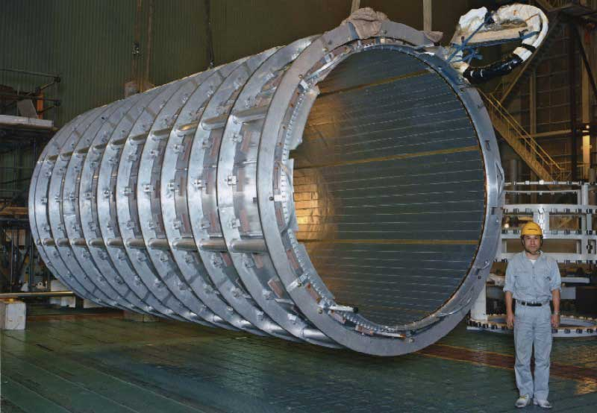
Fig 1: Massive Solenoid (LBL)
One way to boost the field from a wire is to add together the effect of many different wires that are all carrying current in the same direction. This is the basis behind a solenoid, which is a wire that is coiled into a series of loops that are all laid on top of one another (see Figure 1). In the middle of the solenoid, the magnetic fields from all of the wire loops add vectorally to provide a very strong field that goes along the axis of the solenoid. Outside of the solenoid, the magnetic fields tend to cancel each other (the field due to wires on one side is in the opposite direction from the field due to the other). If the wires are close together, and the solenoid aperture is not too large, the magnetic field in the solenoid can be approximated by a uniform field that has the form

B = μ nI

where μ is the permitivity of the material contained in the solenoid if there is something other than air in it), n is the number of wire loops per unit length, and I is the current running through the solenoid.

If a vacuum exists within the solenoid, then the permitivity is that of free space, i.e. μ = μ_{o}. From this equation, we see that we can change the magnetic field by varying the number of turns per unit length, the current running through the solenoid, or by placing a different type of material in the solenoid. For instance, putting an iron core in the solenoid will increase the magnetic field since m for iron is greater than that for free space.

In this week's experiment, we will test this equation by varying the current in two different solenoids. If the equation is correct, a plot of the measured magnetic field versus the current in the solenoid should be a straight line, which has a slope that depends upon the number of turns.

References

1 http://amath.colorado.edu/courses/4380/All/i41.pdf#search='magnetic%20navigation%20history', August 1, 2005.
2 http://www.clas.ufl.edu/users/fgregory/oersted.htm, August 1, 2005.

Procedure

For this activity, you will need two solenoids, a power supply, 3 wires, a multimeter, a ring stand (with clamp), and paper clips.

- Estimate the number of turns per cm on each solenoid.
- Connect one wire from one of the .5 A plugs on power supply to the black lead on the multimeter (the wires on the multimeter need to be set to read current). Connect the other wire from the red lead on the multimeter to one plug on the solenoid. Connect the last wire from the other plug on the solenoid to the other plug on the power supply.
- Place the solenoid in the clamp so that the solenoid is horizontal. Place the iron rod in the solenoid such that one end barely sticks out of one end.
- Turn the multimeter on to the d.c. ammeter setting
- Turn the knob on the power supply to zero. With the ammeter connected to the power supply and the solenoid, turn the power supply on and increase the current until .05 amps is flowing through the solenoid. Place a paper clip on the end of the iron rod. If it sticks, then add one clip at a time until it no longer sticks. Record the number of paper clips. If it does not stick, increase the current to .1 A and try again.
- Increase the current by .05 amps and repeat the measurement with the paper clips. Repeat this until the current in the circuit does not increase.
- Turn off the power supply and return the current knob to zero. Repeat the process 2 more times.
- Replace the solenoid with the other solenoid. Repeat steps 3-6.
- Shut off the power supply and replace all equipment where it was found.
- Plot the data, and test its linearity by performing a best-fit to the data. Record the slopes of the plots.
- Answer the questions on the activity sheet.

Physics Activities | Activity Sheet  Electromagnets

Name:

Number of turns per cm
Solenoid #1 = ______
Solenoid #2 = ______

Number of Paper Clips: Solenoid #1
.05 A | .1 A | .15 A | .20 A | .25 A | .30 A | .35 A | .40 A | .45 A | .50 A | .55A | .60 A

Number of Paper Clips: Solenoid #2
.05 A | .1 A | .15 A | .20 A | .25 A | .30 A | .35 A | .40 A | .45 A | .50 A | .55A | .60 A

Solenoid#1 slope = _______
Solenoid#2 slope = _______

1. How close do your plots come to being linear? What possible sources of error can account for any nonlinear data points?

2. What is the ratio of the slopes from the two solenoids? Does this fit with what you expected? What possible reasons could account for deviations from your expectations?

