Graduate, Spring 2011
Ver 1.10.11a

ARKANSAS STATE UNIVERSITY
DEPARTMENT OF EDUCATIONAL LEADERSHIP,
CURRICULUM, AND SPECIAL EDUCATION

- COURSE INFORMATION

A. ELFN 6773 Introduction to Statistics and Research

B. Professor Dr. Steve Bounds, Asst. Prof.
Educational Leadership
Smith Hall Room 445
870-972-2123
sbounds@astate.edu

II. READINGS

- Primary Texts

Caldwell, Sally (2010). Statistics Unplugged (3rd ed.) Thomson Wadsworth: Belmont, California. ISBN 0-495-60218-3. (Available locally, on the internet, or buy, rent, or buy eBook at http://www.cengagebrain.com/shop/isbn/0495602183?cid=rdl)

- Supplemental Text:

Illowsky, Barbara and Susan Dean (2008). Collaborative Statistics. Connexions: Rice University, TX. (available for download on Blackboard as a pdf file)

C. Software:

Microsoft Office – required. Free to ASU students at http://www2.astate.edu/a/finance-admin/its/services/software.dot

III. PURPOSE OF THE COURSE

A. This course provides the student with:
1. Knowledge of fundamental descriptive statistical concepts and procedures,
2. The capability to apply statistical procedures to the analysis and graphical display of data sets,
3. The ability to apply principles of measurement of human behavior and/or physical phenomena, and
4. An understanding of rudimentary principles of applied research and program evaluation methods.

IV. STANDARDS LINKAGE

A. ELCC Standards

1.3.b, 1.4.b, 2.1.a, 2.2.c, 2.3.c, 3.1.a, 3.3.c, 4.1.c, 4.2.b, 5.1.a, 5.2.a, 5.3.a, 6.1.a

B. Technology Standards for School Administrators (TSSA)

I.D, II.E, III.A, III.C, III.D, V.B, V.D, VI.B

V. COURSE ASSESSMENT AND PERFORMANCE MEASURES

Note: Week is from Monday to Sunday

A. Personal Introduction - 50 points (due no later than 11:59 p.m. Sunday of Week 1)
See Attachment A for details. Microsoft Office is available free to ASU students at http://www2.astate.edu/a/finance-admin/its/services/software.dot

B. Literature Review and Articles * – 200 pts (due no later than 11:59 p.m.m Sunday of Week 3 )
Students will complete a literature review of five scholarly journal articles that relate to online education and submit the URL to the article. See Attachment B, Articles and Lit Review, for more details. [ELCC Standards 1.4.b, 2.2.c, 3.1.a, 4.1.c, 5.1.a, 5.2.a, 5.3.a, 6.1.a; TSSA Standards II.E, III.D, V.B]

C. Question Scenarios * – 200 points (see Blackboard for due dates)
Students will create examples of specified statistical scenarios and provide the solution to each scenario. See Attachment C, Test Questions for Discussion, for more details.
The scenarios for which a question must be developed include:
- Descriptive statistics …………………….…….
- Correlation (Pearson’s r)………………………
- Z-score…………………………………………
- Single-sample t test With σ Known …………..
- Single-sample t test With σ Unknown ………..
- Two-sample Related Samples t test …………..
- Two-sample Independent Samples t-test ……..
- ANOVA ………………………………………
- Chi Square Test of Independence …………….
10) Regression …………………………………….

D. Exams - 500 points (after each module)
Students will have five unit exams, one after each module. The exams will focus mostly on terminology and application, not on manual statistical calculations. Students are permitted to have access to the text, class notes, and statistical software (Excel or SPSS) when taking exams. Statistical calculations should be performed using software. You will have at least two (2) hours in which to complete an exam once it is started and a 24-hour window in which to begin the exam. [ELCC Standards 2.1.a, 2.3.c, 3.1.a, 4.1.c, 4.2.b, 6.1.a; TSSA Standards I.D, III.A, III.D, V.B, V.D, VI.B]

E. Case Analysis – 50 points (due during the last week of class)
Students will respond to a situation which includes research design, data collection, and data reporting methods. The analysis requires a full written report to demonstrate mastery of the principles of research design and statistical analysis. [ELCC Standards 1.3.b, 1.4.b, 2.1.a, 2.2.c, 2.3.c, 3.1.a, 3.3.c, 4.1.c, 4.2.b, 5.1.a, 5.2.a, 5.3.a; TSSA Standards I.D, II.E, III.A, III.C, III.D, V.B, V.D, VI.B]

*Mastery Learning Assignments: In the event that the grade on a “Mastery Learning” assignment is lower than a B, a student, using feedback from the professor or teaching assistant, may make corrections and resubmit the assignment within three days after receiving feedback on the initial submission. No grade higher than a B will be possible on a resubmitted assignment.

F. Late Submission Policy:

Except in cases of serious extenuating circumstances, tardy work will not be accepted. Instructional assistants and/or the course professor will determine if the excuse for late work rises to the level of being a “serious extenuating circumstance.”

G. Grading Method
Personal Introduction 50 points
Literature review 200 points
Question Scenarios (20 pts @) 200 points
Case Analysis 50 points
Exams (100 pts @) 500 points
Total: 1000

A: 900+ points
B: 800 - 899 points
C: 700 – 799 points
D: 600 – 699 points

VI. TENTATIVE COURSE OUTLINE

Module/  Lesson | Date  Begins | Topic(s) Covered
1.1 | Jan 10 | Introduction and procedures (Caldwell, ch 1, pp 1-16)
1.2 |  | Sampling and Data (Illowsky, ch 1, pp 11-48)
1.3 |  | Descriptive Statistics (Caldwell, ch 2, pp 19-51; Illowsky, ch 2, pp 49-96)
2.1 |  | Correlation (Caldwell, ch 12, pp 274-293)
2.2 |  | Distribution Shapes (Caldwell, ch 3, pp 52-69)
2.3 |  | The Normal Curve & Z Scores (Caldwell, ch 4, pp 71-91)
3.1 |  | Hypothesis testing & Single-sample t-test (Caldwell, ch 7, pp149-177)
3.2 |  | Hypothesis testing & Two-sample t-tests (Caldwell, ch 8, pp 178-202)
3.3 |  | Alternative Hypothesis (Caldwell, ch 9, pp 203-220)
4.1 |  | Analysis of variance (Caldwell, ch 10, pp 221-254)
4.2 |  | Chi-Square tests (Caldwell, ch 11, pp 255-273)
5.1 |  | Regression analysis (Caldwell, ch 12, pp 293-302)
5.2 |  | Fundamental Concepts (Caldwell, ch 5, pp 93-107)
5.3 |  | Confidence intervals (Caldwell, ch 6, pp 108-147)

VII. SPECIAL CONSIDERATIONS AND/OR FEATURES OF THIS COURSE

A. Instructional methods will include cooperative learning, video lectures, class discussions/debates, journal reading, self-directed learning, and a data-based research or program evaluation project in order to increase learning and to accommodate a variety of learning styles.
B. Students are required to access Blackboard to check for announcements, engage in focused discussions of research topics, and review the class lectures, and submit class assignments.
C. Students are required to use word processing to prepare both the project and the literature reviews. Word processing files must be saved as Microsoft Word files or as rtf files. Microsoft Office, which includes Word and Excel, is available free for ASU students. (http://www2.astate.edu/a/finance-admin/its/services/software.dot)
D. Students are required to use Statistical Package for the Social Sciences (SPSS) or Microsoft Excel Data Analysis to analyze data for the optional project.
E. Students must submit original work (not from other sources and not from other coursework) in order to complete the requirements for this class. All work must be submitted in electronic format.
F. Students are expected to be in “attendance”. Class material will be available online through Blackboard. Students are expected to complete all assignments during the specified time.

NOTE: This syllabus is subject to change at any time during the course.

VIII. PROCEDURES TO ACCOMMODATE STUDENTS WITH DISABILITIES

If a student needs course adaptation or accommodations due to a disability, or has emergency medical information to share, or needs special arrangements, then that student should notify the professor as soon as possible.

IX. REFERENCES

Chase, C. (1984). Elementary Statistical Procedures (3rd edition). New York: McGraw-Hill.

Enger, J. and Howerton, D. (1992). User Friendly Guide to Descriptive Statistics (3rd edition). Needham Heights, MA: Ginn.

Ferguson, F. and Takane, Y. (1989). Statistical Analysis in Psychology and Education. New York: McGraw-Hill.

Hopkins, C. and Antes, R. (1990). Educational Research: A Structure of Inquiry. Columbus, Ohio: Charles E. Merrill.

Welkowitz, J., Ewen, R. and Cohen, J. (2000). Introductory Statistics for the Behavioral Sciences (5th edition). Fort Worth, TX: Harcourt Brace College Publishers.

Witte, R. (2001). Statistics (6th edition). Fort Worth, TX: Harcourt Brace College Publishers.
Attachment A
Creating your Personal Introduction on the Discussion Board

Since this is an online course and we will not be “seeing” one another, this activity is designed to help you get to know one another. You will create your Personal Introduction as a Word document with your picture embedded in the document and paste the contents (excluding the picture) into the Discussion Board where your class members can view it, so feel free to share information about yourself, your family, your goals, etc. Once the course is finished the personal introductions are deleted from the Discussion Board. If you don’t know how to embed a photo into a Word document instructions are provided later in this attachment. The file name for the Word document should be LastNameFirstName_section number_Intro. So if your name is Joe Harris and you are in section 008 of this class your filename would be HarrisJoe_008_Intro. Attach the Word document to the discussion board post.

The following items are the minimum requirements for your introduction.
>Your name
>Town in which you reside
>Degree(s) held & major(s)
>Degree sought & major
>Your employer and job title/duties
>Some interesting or little known fact about you

>In the Word document: A photograph of you
See the video Resizing Photo in Lesson 1 if you need to resize your photo before uploading.

>Optional: Personal stuff
You can use this section for any other information you would like to share with the group. Remember, only the class members can “see” this information so use the space to tell about your kids/grandkids/pets/hobbies/interests, etc.

Posting Your Personal Introduction

Go to Discussion Board
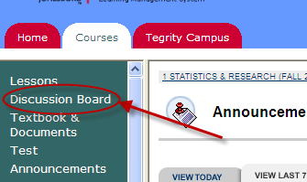

Click on Personal Introductions
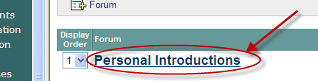

Click on Thread
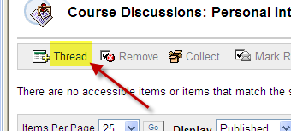

In the Subject box enter your name and in the Message box enter your personal introduction
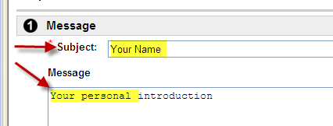

Scroll down below the Message Box to Attach a file
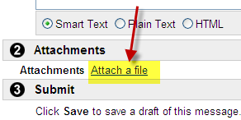

Locate and attach your personal introduction in Word with the embedded picture
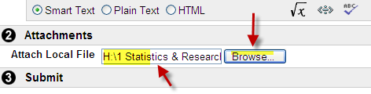

Click on Submit
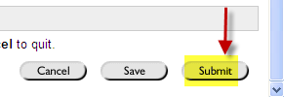

Congratulations! You have entered your personal introduction onto the Discussion Board and have attached it as a Word document with the embedded picture to your post.

Inserting Your Picture Into a Word Document

Open a blank page

Click on the Insert tab
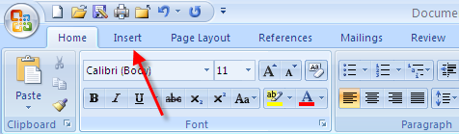

Click on Picture


Locate the picture in your files
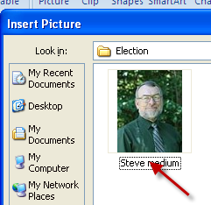

Click on Insert
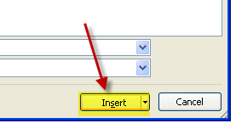

The picture will be inserted into your Word document.

It can be resized in Word by clicking on the picture which causes the “sizer” buttons to appear
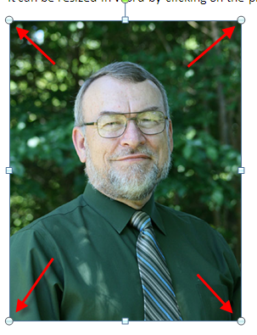

Click and hold on one of the “sizer” buttons and drag it to the desired size


The picture is now inserted and sized. You can now add your text to the page. So that it looks something like this:

Name: Steve Bounds
Town: Jonesboro, Arkansas
Degrees: A.A., B.A.(Bible), M.S. (Biology), S.C.C.T. (Community College Teaching), Ed.S. (Educational Adminstration), Ed.D. (Educational Leadership)
Degree Sought: None
Employer: Arkansas State University – Asst Prof – teach school district administration classes and statistics
Little Known Fact: First person to receive the SCCT degree from ASU

Hi, my name is Steve Bounds and I live in Jonesboro, Arkansas. I am not currently seeking a degree which is probably good since I’ve had practically every class ASU offers. I hold six degrees, the A.A. from Crowley’s Ridge College, the B.A. in Bible from Oklahoma Christian University, the M.S. in biology from ASU, the Specialist in Community College Teaching degree from ASU, the Ed.S. in education administration from ASU, and the Ed.D in educational leadership from ASU. I currently am employed by ASU to teach courses in educational administration and leadership. Some of the courses for which I am responsible include School Business Management, School District Administration, Supervised Internship, Planning and Resource Allocation, and Introduction to Statistics and Research. A little known fact about me is that I am the first person to receive the SCCT degree from ASU and the first person to receive a minor in Greek from OCU.

On a personal note, I have no children so you won’t see pictures of my grandchildren here on the homepage ☺. I do, however, have five sisters and plenty of nieces, nephews, and great-nieces and nephews. I was raised in the hills of Arkansas and enjoy the outdoors, especially the rivers and streams. I taught high school math and science classes for ten years before becoming a high school principal. I served in that capacity for four years before being promoted (or demoted, depending upon your point of view) to the position of superintendent in the district. Eight years later I was recruited to be an assistant superintendent for business affairs in a much larger district and did that for four years before being recruited to be a superintendent again. I’ve taught as an adjunct for several colleges and universities (a total of eight) while working in the K-12 environment. I retired from K-12 education and started a new career in 06-07 at Henderson State University teaching educational leadership classes. I had the opportunity to “come home” to ASU during the 07-08 academic year.

My philosophy of teaching is fairly simple. I don’t believe I should not waste the students’ time but should make the course relevant and worthwhile. I have an open-door philosophy which means the student has access to me. I give students my personal phone number so they can reach me whenever there is a question. I do go to the hill farm fairly frequently and cell service is sometimes limited; however, students may leave a message and I’ll return the call as soon as possible.

Attachment B
Articles and Lit Reviews

Students will complete a literature review of five scholarly journal articles that relate to online education as stated in the syllabus. The body of the literature review should be double-spaced and should include the appropriate citation (single-spaced) for each article using APA format AND the URL link to the article in the ASU library so the instructor can click on the link and be taken to the article. You will have only one submission that contains all five reviews for this assignment. Submit to the Digital Drop Box.

Lit Review Filename
The filename for the literature review should be assigned as follows (where you substitute your name):
YourLastNameFirstName_section number_LReview

For example, if your name is Joe Harris and you are in section 008 of this class your filename for your literature review would be HarrisJoe_008_LReview.

NOTE: This is how you name the actual file.

Example of Article Review (abbreviated)

Ima Stoodent
Article Reviews
ELFN 6773 Introduction to Statistics and Research
Fall 2010

McGuinness, T., & Noonan, P. (2004). Top 10 reasons to take your graduate program in psychiatric nursing online. Journal of Psychosocial Nursing & Mental Health Services. Retrieved July 11, 2010 from:
http://lawrence.library.astate.edu:2048/login?url=http://search.ebscohost.com/login.aspx?direct=true&db=c8h&AN=2005034232&site=ehost-live

Psychiatric Nursing Online
The purpose of this article is to show how a web-based graduate nursing program will benefit those in psychiatric studies. It addresses the impact on psychiatric graduate programs, the specific needs of psychiatric nurses, as well as, answers questions t………………….

<new page>
MaHoney, J. (2006). Do you feel like you belong? An on-line versus face-to-face pilot study.
Visions. Retrieved July 11, 2010, from:
http://lawrence.library.astate.edu:2048/login?url=http://search.ebscohost.com/login.aspx?direct=true&db=c8h&AN=2009223247&site=ehost-live

A Study on Belonging
Like the age old concern of those being home schooled not benefitting from the social aspects of public education, comes a new concern regarding belonging, with the surge of online education. The writer states, “Sense of belonging can be a strong motivational factor needed to successfully complete an academic course” (Mahoney, 2006, p.18). Whether or not, then, an online course covers all the……………………………………
<new page>
Fearing, A., & Riley, M. (2005). Graduate students' perceptions on online teaching and relationship to preferred learning styles. MEDSURG Nursing. Retrieved July 11, 2010 from:
http://lawrence.library.astate.edu:2048/login?url=http://search.ebscohost.com/login.aspx?direct=true&db=c8h&AN=2009090415&site=ehost-live

Online Teaching and Preferred Learning Styles
While an educator today might say she is teaching one particular math lesson, she knows that she will need to present the material in a way that stimulates those with attention deficit disorders, assists the mentally challenged, and motivates the scholarly students. The same idea holds true of online professors, who must understand the different learning styles of their students………

Be sure to “test” your links before submitting your assignment to ensure that they work properly!

Locating the URL address to Articles in the Library
By Dr. Steve Bounds

Go to the ASU home page at www.astate.edu

Click on A-Z Index


Click on Library
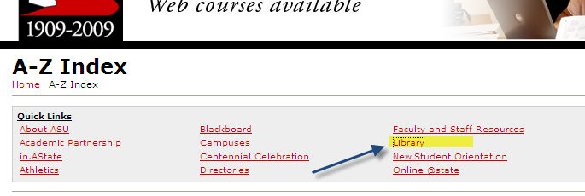

Click on Article Databases
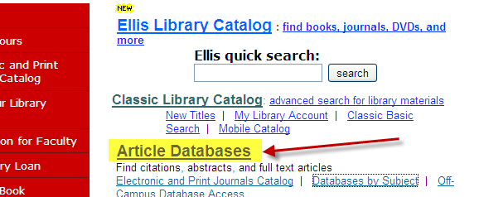

Click on Academic Search Complete
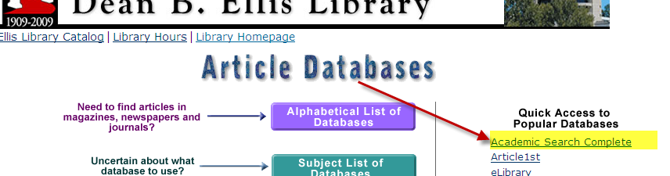

Enter your ASU email address and your student id number PRECEDED by 7, then click Submit
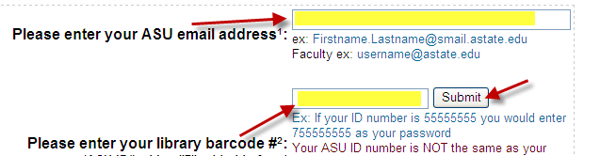

Enter your search phrase(s)
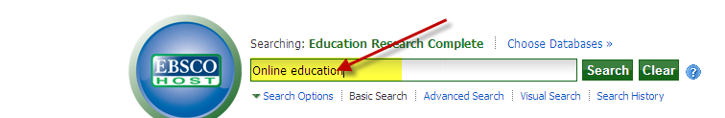
Scroll down and check Full Text
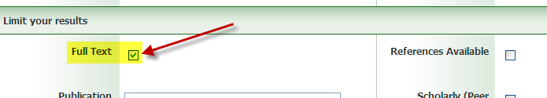
Click on Search

Locate an article for your needs and click on the title
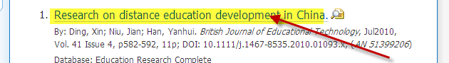

Click on Permalink to obtain the URL to the article
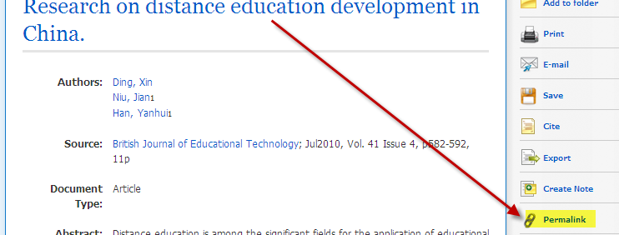

Click on the http address in the box to highlight it. Then press Ctrl C to copy the link (or use the Edit – Copy commands on the menu bar)
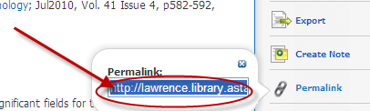

Open your Word document, place the cursor where you want the URL pasted to, and press Ctrl V to paste the link (or use the Edit – Paste commands on the menu bar)
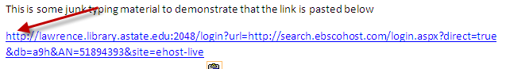

Back in the browser Click on PDF Full Text to open the file and read it
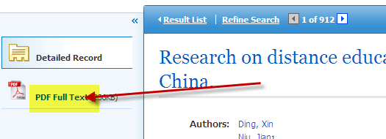

Congratulations! You have pasted the URL that links to the article in your Word document. Be sure to test your links before you submit your assignment to ensure that they are working correctly.

Attachment C
“Test Questions”

Students will create a four-choice multiple-choice “test question” for each scenario listed below using “real-life” data from their workplace to demonstrate mastery of specified statistical scenarios and provide the solution to the question.

The scenarios for which a question must be developed include:
- Descriptive statistics …………………….…….
- Correlation (Pearson’s r)………………………
- Z-score…………………………………………
- Single-sample t test With σ Known …………..
- Single-sample t test With σ Unknown ………..
- Two-sample Related Samples t test …………..
- Two-sample Independent Samples t-test ……..
- ANOVA ………………………………………
- Chi Square Test of Independence …………….
10) Regression …………………………………….
NOTE: Weeks are Monday to Sunday

See sample on following page.

IMPORTANT:
- The “test question” must be typed into a Word document.
- You must provide the solution using either Excel Data Analysis or SPSS (now known as PASW) by copying and pasting the results into your Word document.
- Save your document using the filename structure listed below.
- Copy and paste the question (without the solution) into the Discussion Board under the appropriate topic.
- Attach the Word document file (that contains the solution) to the post on the Discussion Board.

Case Scenario Filenames
Filenames for the case scenarios should be assigned as follows (where you substitute your name):
YourLastNameFirstName_section number_CS1
YourLastNameFirstName_section number_CS2
YourLastNameFirstName_section number_CS3
Etc.
Where the number corresponds to the type of scenario listed above. (1=descriptive statistics; 2=correlation; 3=z-score; 4=single-sample t test with σ known; etc

For example, if your name is Joe Harris and you are in section 1008 of this class your filename for your descriptive statistics scenario would be HarrisJoe_1008_CS1.

SAMPLE TEST QUESTION – Descriptive Statistics

A preschool teacher with 18 children in her caseload wants to know the average age of the children. Their chronological ages in months are: 36, 38, 39, 40, 41, 42, 45, 49, 50, 50, 52, 53, 54, 55, 57, 58, 60, 60, 68, and 70

The mean or average age, rounded to the nearest whole number, is _
A) 40 months
B) 51 months
C) 60 months
D) 55 months

The correct answer is B) 51 months. Add the children’s ages together (1017) and divide by the number of children (20). 1017/20= 50.85 then round to the nearest month; 51 months.
 |  | Average Age of Preschoolers
 |  | Mean | 50.85
 |  | Standard Error | 2.181592
 |  | Median | 51
 |  | Mode | 50
 |  | Standard Deviation | 9.756374
 |  | Sample Variance | 95.18684
 |  | Kurtosis | -0.62367
 |  | Skewness | 0.259245
 |  | Range | 34
 |  | Minimum | 36
 |  | Maximum | 70
 |  | Sum | 1017
 |  | Count | 20

SAMPLE TEST QUESTION – Related Samples t-test

John is taking a bowling course as an elective in college. He wonders whether the course significantly improves student’s bowling averages. He records his and seven fellow students’ bowling averages at the beginning of the course and again at the end of the course. Based on the data below, what would you conclude?

Student | Before | After
 | Course | Course
1 | 68 | 91
2 | 154 | 155
3 | 145 | 152
4 | 183 | 190
5 | 123 | 134
6 | 167 | 175
7 | 76 | 99
8 | 108 | 104

- Scores before the course are significantly better than after the course
- Scores after the course are significantly better than before the course
- There is no significant difference in scores before and after the course
- None of the above

Null hypothesis: There is no significant difference between bowling scores before the class and after the class.

t-Test: Paired Two Sample for Means
 | Variable 1 | Variable 2
Mean | 128 | 137.5
Variance | 1748.571 | 1351.143
Observations | 8 | 8
Pearson Correlation | 0.978767
Hypothesized Mean Difference | 0
df | 7
t Stat | -2.81896
P(T<=t) one-tail | 0.012906
t Critical one-tail | 1.894579
P(T<=t) two-tail | 0.025812
t Critical two-tail | 2.364624

Correct answer: b, since the calculated t Stat (2.81896) is greater than the t Critical two-tail (2.364624) we reject the null hypothesis and conclude that there is significant difference. Looking at the means we see that mean scores were higher after the class.

